**WEEK 4**

**Spring REST using Spring Boot 3**

**Create a Spring Web Project using Maven**

**Step 1:** Create a Eclipse Project using Spring Initializer

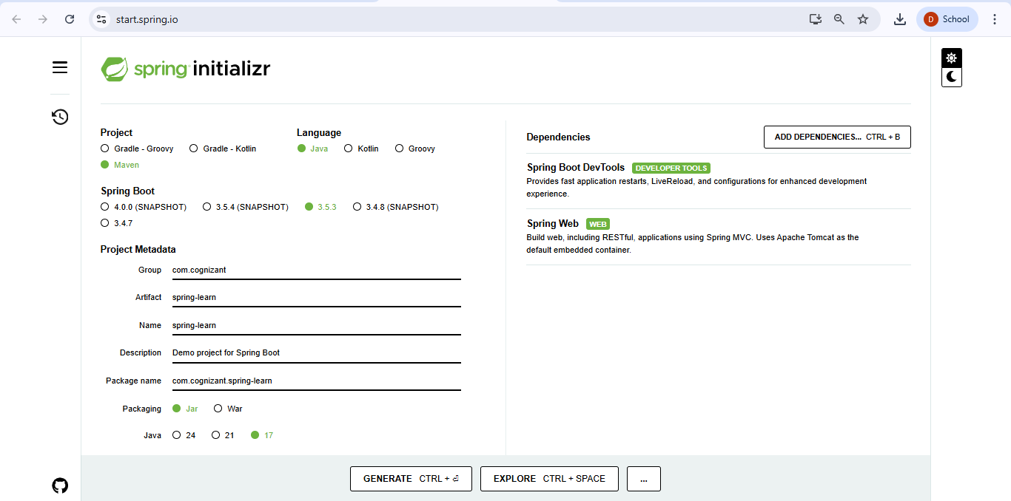

**Step 2:** Extract the zip in root folder to Eclipse Workspace and Import the project in Eclipse

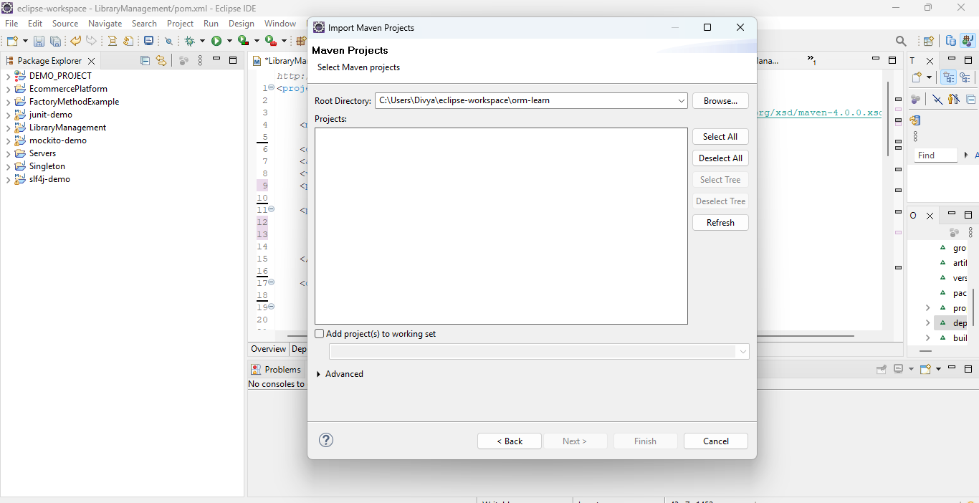

**CODING:**

**SpringApplication.java**

package com.cognizant.spring_learn;

import org.springframework.boot.SpringApplication;

import org.springframework.boot.autoconfigure.SpringBootApplication;

@SpringBootApplication

public class SpringLearnApplication {

public static void main(String[] args) {

SpringApplication.run(SpringLearnApplication.class, args);

System.out.println("SpringLearnApplication started...");

}

}

OUTPUT:

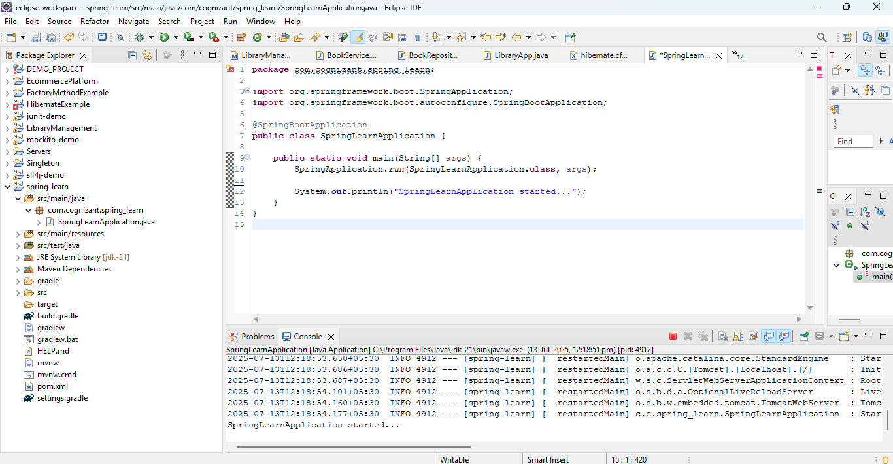

**Hello World RESTful Web Service**

HelloController.java

package com.cognizant.spring_learn.controller;

import org.slf4j.Logger;

import org.slf4j.LoggerFactory;

import org.springframework.web.bind.annotation.GetMapping;

import org.springframework.web.bind.annotation.RestController;

@RestController

public class HelloController {

private static final Logger LOGGER = LoggerFactory.getLogger(HelloController.class);

@GetMapping("/hello")

public String sayHello() {

LOGGER.info("START - sayHello()");

String response = "Hello World!!";

LOGGER.info("END - sayHello()");

return response;

}

}

application.properties

server.port=8083

SpringLearnApplication.java

package com.cognizant.spring_learn;

import org.springframework.boot.SpringApplication;

import org.springframework.boot.autoconfigure.SpringBootApplication;

import org.springframework.context.annotation.ComponentScan;

@SpringBootApplication

@ComponentScan("controller") // Or "com.cognizant.spring_learn.controller" if using full package

public class SpringLearnApplication {

public static void main(String[] args) {

SpringApplication.run(SpringLearnApplication.class, args);

}

}

OUTPUT:

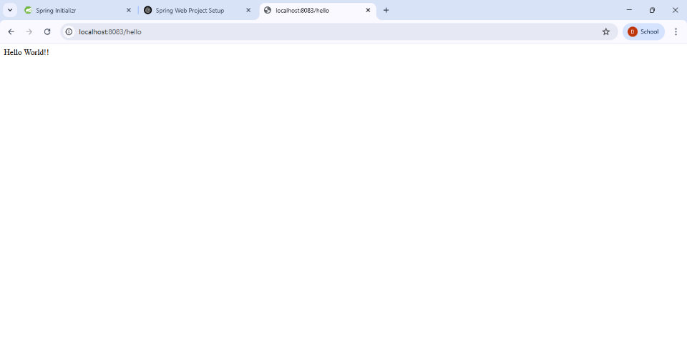

**REST - Country Web Service**

country.xml

<?xml version="1.0" encoding="UTF-8"?>

<beans xmlns="http://www.springframework.org/schema/beans"

xmlns:xsi="http://www.w3.org/2001/XMLSchema-instance"

xsi:schemaLocation="http://www.springframework.org/schema/beans

https://www.springframework.org/schema/beans/spring-beans.xsd">

<bean id="country" class="com.cognizant.spring_learn.Country">

<property name="code" value="IN"/>

<property name="name" value="India"/>

</bean>

</beans>

Country.java

package com.cognizant.spring_learn;

public class Country {

private String code;

private String name;

public Country() {

}

public String getCode() {

return code;

}

public void setCode(String code) {

this.code = code;

}

public String getName() {

return name;

}

public void setName(String name) {

this.name = name;

}

}

CountryController.java

package com.cognizant.spring_learn.controller;

import com.cognizant.spring_learn.Country;

import org.slf4j.Logger;

import org.slf4j.LoggerFactory;

import org.springframework.context.ApplicationContext;

import org.springframework.context.support.ClassPathXmlApplicationContext;

import org.springframework.web.bind.annotation.RequestMapping;

import org.springframework.web.bind.annotation.RestController;

@RestController

public class CountryController {

private static final Logger LOGGER = LoggerFactory.getLogger(CountryController.class);

@RequestMapping("/country")

public Country getCountryIndia() {

LOGGER.info("START - getCountryIndia()");

ApplicationContext context = new ClassPathXmlApplicationContext("country.xml");

Country country = (Country) context.getBean("country", Country.class);

LOGGER.info("END - getCountryIndia()");

return country;

}

}

SpringLearnApplication.java

@SpringBootApplication

@ComponentScan("com.cognizant.spring_learn")

public class SpringLearnApplication {

public static void main(String[] args) {

SpringApplication.run(SpringLearnApplication.class, args);

}

}

OUTPUT:

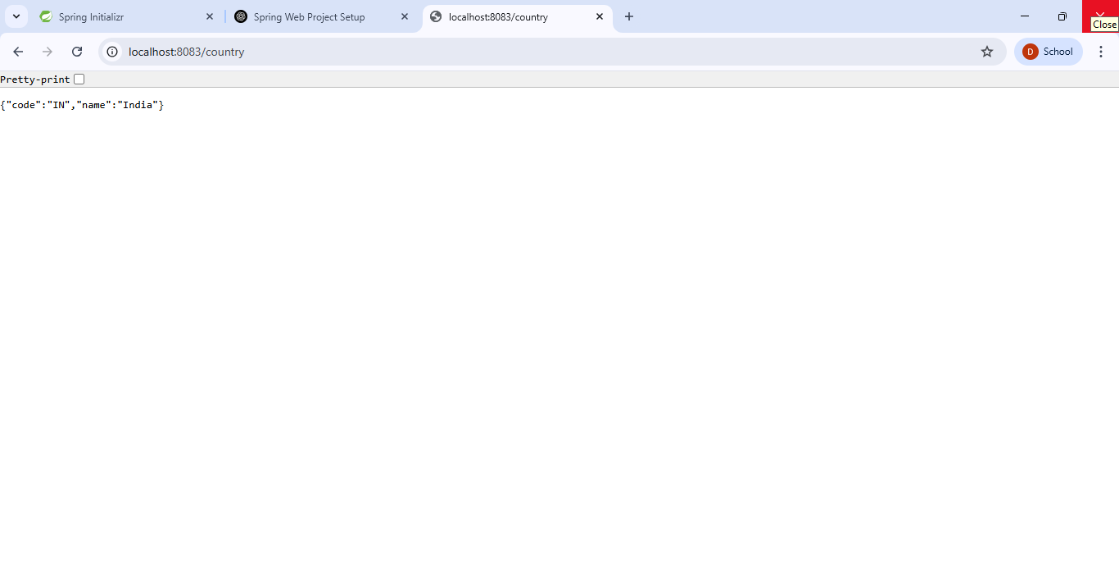

**REST - Get country based on country code**

Country.java

package com.cognizant.spring_learn;

public class Country {

private String code;

private String name;

public Country() {

System.out.println("Inside Country Constructor.");

}

public String getCode() {

System.out.println("Getting code");

return code;

}

public void setCode(String code) {

System.out.println("Setting code");

this.code = code;

}

public String getName() {

System.out.println("Getting name");

return name;

}

public void setName(String name) {

System.out.println("Setting name");

this.name = name;

}

@Override

public String toString() {

return "Country{" +

"code='" + code + '\'' +

", name='" + name + '\'' +

'}';

}

}

country.xml

<?xml version="1.0" encoding="UTF-8"?>

<beans xmlns="http://www.springframework.org/schema/beans"

xmlns:xsi="http://www.w3.org/2001/XMLSchema-instance"

xsi:schemaLocation="http://www.springframework.org/schema/beans

https://www.springframework.org/schema/beans/spring-beans.xsd">

<bean id="country1" class="com.cognizant.spring_learn.Country">

<property name="code" value="IN" />

<property name="name" value="India" />

</bean>

<bean id="country2" class="com.cognizant.spring_learn.Country">

<property name="code" value="US" />

<property name="name" value="United States" />

</bean>

<bean id="country3" class="com.cognizant.spring_learn.Country">

<property name="code" value="DE" />

<property name="name" value="Germany" />

</bean>

<bean id="country4" class="com.cognizant.spring_learn.Country">

<property name="code" value="JP" />

<property name="name" value="Japan" />

</bean>

<bean id="countryList" class="java.util.ArrayList">

<constructor-arg>

<list>

<ref bean="country1"/>

<ref bean="country2"/>

<ref bean="country3"/>

<ref bean="country4"/>

</list>

</constructor-arg>

</bean>

</beans>

CountryService.java

package com.cognizant.spring_learn.service;

import com.cognizant.spring_learn.Country;

import org.springframework.context.ApplicationContext;

import org.springframework.context.support.ClassPathXmlApplicationContext;

import org.springframework.stereotype.Service;

import java.util.List;

@Service

public class CountryService {

public Country getCountry(String code) {

ApplicationContext context = new ClassPathXmlApplicationContext("country.xml");

List<Country> countryList = (List<Country>) context.getBean("countryList");

return countryList.stream()

.filter(c -> c.getCode().equalsIgnoreCase(code))

.findFirst()

.orElse(null);

}

}

CountryController.java

package com.cognizant.spring_learn.controller;

import com.cognizant.spring_learn.Country;

import com.cognizant.spring_learn.service.CountryService;

import org.slf4j.Logger;

import org.slf4j.LoggerFactory;

import org.springframework.beans.factory.annotation.Autowired;

import org.springframework.web.bind.annotation.*;

@RestController

public class CountryController {

private static final Logger LOGGER = LoggerFactory.getLogger(CountryController.class);

@Autowired

private CountryService countryService;

@GetMapping("/country/{code}")

public Country getCountry(@PathVariable String code) {

LOGGER.info("START - getCountry()");

Country country = countryService.getCountry(code);

LOGGER.info("END - getCountry()");

return country;

}

}

SpringLearnApplication.java

package com.cognizant.spring_learn;

import org.springframework.boot.SpringApplication;

import org.springframework.boot.autoconfigure.SpringBootApplication;

import org.springframework.context.annotation.ComponentScan;

@SpringBootApplication

@ComponentScan("com.cognizant.spring_learn")

public class SpringLearnApplication {

public static void main(String[] args) {

SpringApplication.run(SpringLearnApplication.class, args);

}

}

OUTPUT:

